Janice Ainembabazi

Southern New Hampshire University

CS-340-18683-M01 Client/Server Development

Prof. Jeff Sanford

December 1st 2024

* Added an HTML component to create a unique identifier for my dashboard.
* Imported the CRUD Python module that I created for Project One.

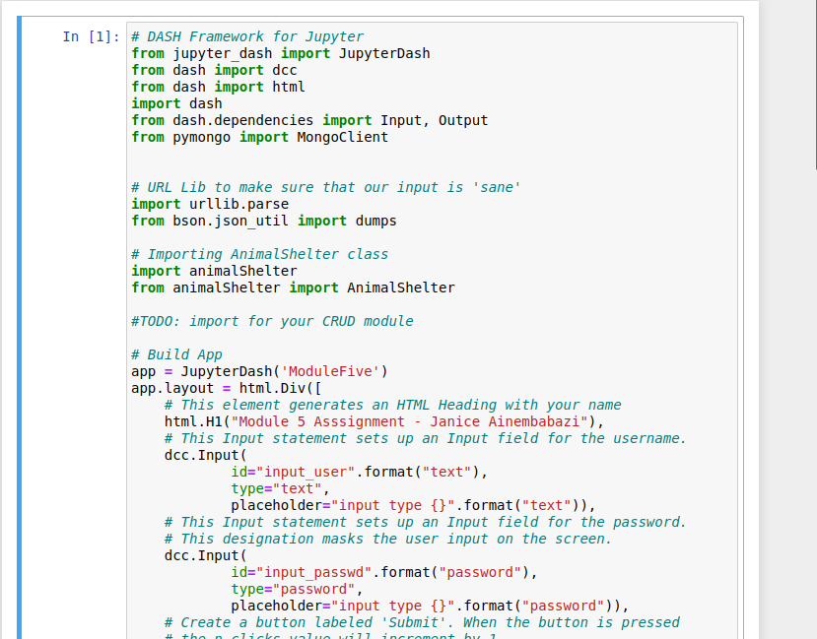

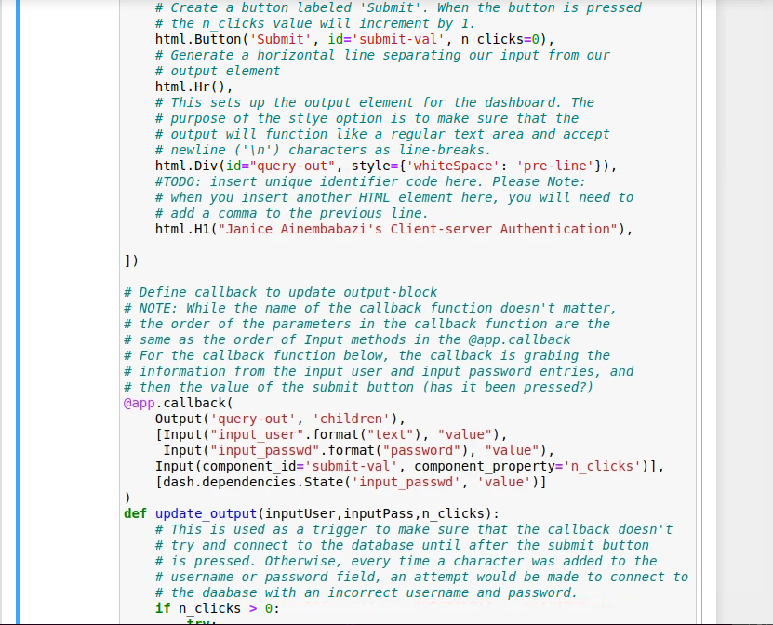

* Added the functionality in the callback routine for instantiation of my CRUD object
* Added functionality to test my dashboard connection to MongoDB.

